**Experiment 4: Implement External CSS with classes and IDs.**

|  |  |  |  |
| --- | --- | --- | --- |
|  | **Course Name: Web Technology Lab** | **EXPERIMENT NO. 4** | |
| **Course Code: 23CP306P**  **Faculty: Punit Gupta** | **Branch: CSE** | **Semester: V** |

Experiment 4: Implement External CSS with classes and IDs.

**Code: styles.css**

|  |
| --- |
| body {  margin: 0;  font-family: Arial, sans-serif;  background-color: #f9f9f9;  display: flex;  flex-direction: column;  min-height: 100vh;  }  header {  background-color: #222;  padding: 15px 30px;  display: flex;  justify-content: space-between;  align-items: center;  }  header a {  color: white;  text-decoration: none;  font-weight: 500;  margin: 0 10px;  display: inline-block;  }  header a:hover {  color: #110214;  }  mark{  background-color: yellow;  }  blockquote{  font-style: italic;  color: #666;  margin: 40px auto 20px;  max-width: 500px;  }  hr{  margin: 40px auto;  width: 80%;  }  iframe{  border:1px solid #ccc;  border-radius: 8px;  }  footer {  text-align: center;  padding: 15px;  background-color: #f1f1f1;  color: #444;  }  table {  border-collapse: collapse;  margin-top: 10px;  }  th, td {  padding: 8px;  text-align: center;  }  a {  color: blue;  text-decoration: none;  }  a:hover {  text-decoration: underline;  }  h1, h2, h3 {  color: black;  text-align: center;  }  ul{  list-style-type: circle;  text-align: left;  max-width: 600px;  margin: 20px auto;  }  ol{  text-align: left;  max-width: 600px;  margin: 20px auto;  }  legend {  font-weight: 700;  color: #444;  font-size: 1rem;  padding: 0 10px;  background: white;  border-radius: 4px;  margin-bottom: 10px;  }  fieldset {  padding: 20px 25px;  margin-bottom: 30px;  border: 1.5px solid #ccc;    border-radius: 8px;  }  button {  margin-top: 25px;  width: 100%;  padding: 12px 0;  font-size: 16px;  background-color: #d17eb0;  border: none;  border-radius: 6px;  color: #222;  font-weight: 700;  cursor: pointer;  transition: background-color 0.3s;  }  button:hover {  background-color: #b914c5;  }  form {  background: white;  padding: 30px 25px;  border-radius: 10px;  width: 360px;  box-shadow: 0 5px 15px rgba(0,0,0,0.1);  }  p{  text-align: center;  }  label {  display: block;  margin-top: 15px;  font-size: 14px;  color: #333;  cursor: pointer;  }  input[type="text"],textarea,  select, input[type="email"],  input[type="password"],input[type="tel"],  input[type="url"],  input[type="file"],  input[type="color"],  input[type="range"],  input[type="search"],  input[type="date"],  input[type="month"]{  width: 100%;  padding: 10px;  margin-top: 6px;  border-radius: 5px;  border: 1px solid #ccc;  font-size: 14px;  box-sizing: border-box;  transition: border-color 0.3s;  }  input[type="checkbox"] {  margin-right: 8px;  vertical-align: middle;  }  label[for="remember"] {  display: inline-block;  font-weight: normal;  margin-top: 15px;  cursor: pointer;  }  select[multiple] {  height: 70px;  }  .home-div  {  display: flex;  align-items: center;  }  .icon  {  border-radius: 50%;  margin-right: 10px;  }  .nightcode  {  color: white;  margin: 0;  }  .h1-salesforce  {  color: #0B5CAB;  }  .h3-about  {  margin-top: 50px;  }  .p-about  {  margin-bottom: 10px;  }  .main-about  {  text-align: center;  padding: 50px;  }  .main-review {  flex-grow: 1;  display: flex;  justify-content: center;  align-items: center;  padding: 40px 20px;  }  #div-intro  {  text-align: center;  padding: 50px 20px;  }  #home-img  {  border-radius: 12px;  box-shadow: 0 4px 8px rgba(0,0,0,0.2);  margin-top: 20px;  }  #profile-link  {  color: white;  background-color: #0B5CAB;  padding: 8px 8px;  border-radius: 8px;  text-decoration: none;  text-align: center;  }  #profile-img {  border-radius: 50%;  }  #rank  {  margin: 10px 0;  }  #div-IN-UP  {  text-align: center;  margin-top: 20px;  font-size: 14px;  }  #p-gender  {  margin-top: 15px;  font-weight: 600;  color: #333;  }  #label-radio  {  margin-right: 15px;  cursor: pointer;  } |

home.html

about.html

media.html

Profile.html

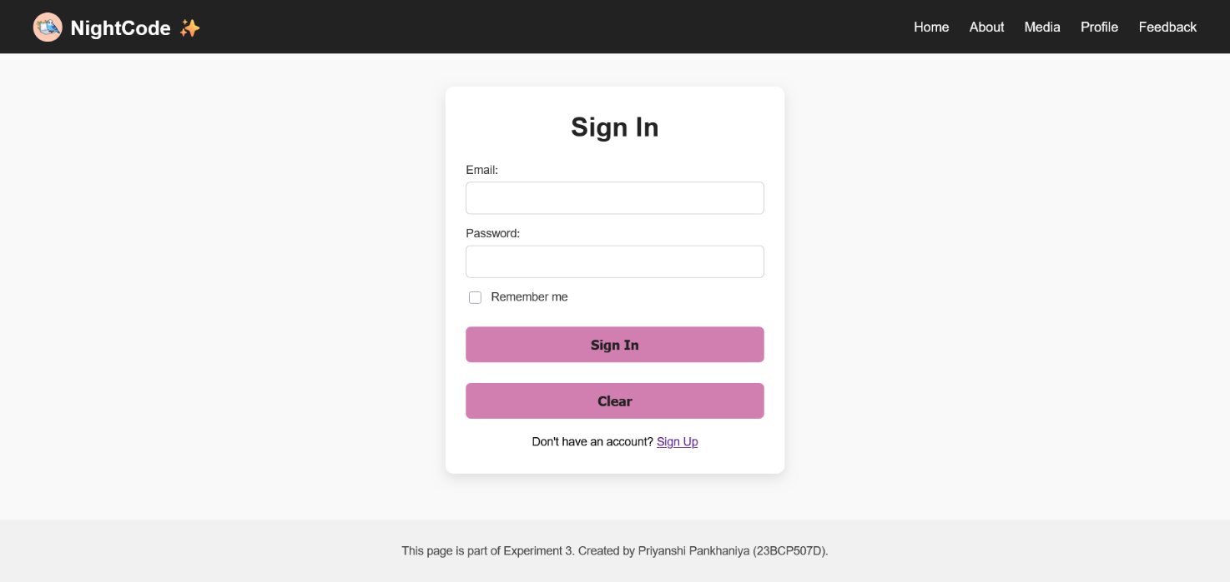

Signin.html

review.html

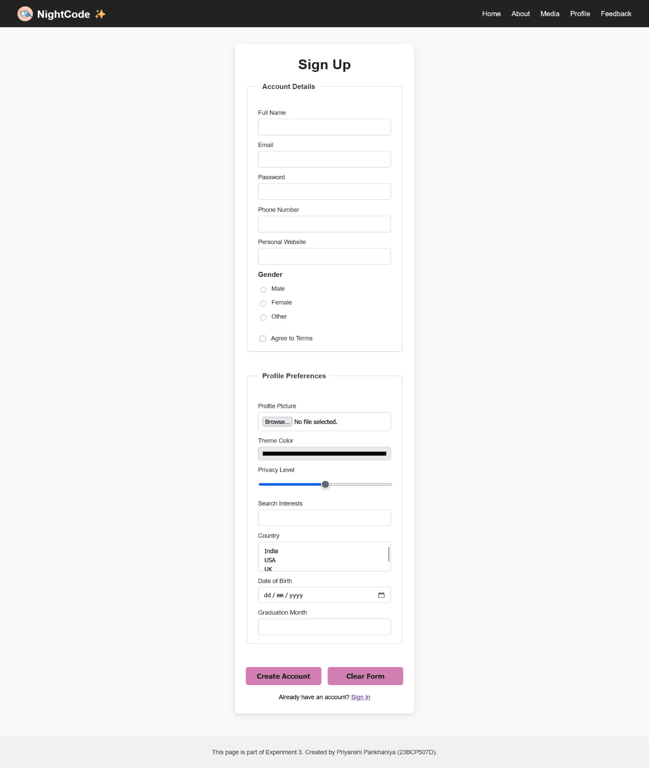

SignUp.html